**Algorithms and Advanced Programming Continuous Assessment**

**Module Name:** Algorithms and Advanced Programming (AAP)

**Academic Year:** 2021/22, Semester II

**Programs:** HDSDEV_SEP, HDCSDEV_INT

**Total Marks:** 100 marks with 50% contribution to the final result

**Submission Deadline:** Week 12 (11-04-2022 @ 23:55)

Lecturer William Clifford

Jamal Massalha

21118426

**Learning Outcomes:**

|  |  |
| --- | --- |
| LO1 | Use iterative and recursive techniques to design and implement sorting and searching algorithms. |
| LO2 | Conduct in depth algorithm analysis in terms of time complexity and present the results of analysis. |
| LO3 | Evaluate algorithms, identify an algorithm from a range of possible options, and implement the algorithm to solve computational problems in particular contexts. |
| LO4 | Identify and apply best practices including exception handling and design patterns in the implementation of software solutions to solve real-world problems. |

**Project Background:**

Each student is expected to complete the following tasks for the following sets of data. Each dataset contains 6 columns and 10,000 rows. Your assigned dataset is dependent on your student number. Match each part of your student number to the relevant descriptions of what dataset you should use and how you should sort, transform, and retrieve your data.

**Note:** the development of the software should be your own. It is okay to use samples from the lectures and labs, but you should highlight the parts of development that are your own. You should not use code developed by other students also completing the assessment.

**Choosing your dataset**

Your dataset will be chosen based on the final digit of your student number. The table below highlights what number is associated with what dataset. It also highlights the columns in each dataset.

Jama Massalha

21118426

|  |  |  |  |  |  |  |  |
| --- | --- | --- | --- | --- | --- | --- | --- |
| last digit | Dataset file name | Column 1 | Column 2 | Column 3 | Column 4 | Column 5 | Column 6 |
| 0  3  6  9 | Staff.csv | emp_no (integer) | first_name (String) | second_name (String) | birth_date (YYYY-MM-DD) | wage (float) | hire_date (YYYY-MM-DD) |
| 1  4  7 | Film.csv | film_id (integer) | genre (String) | release_date (YYYY-MM-DD) | title (String) | length (float) | rental_cost (float) |
| 2  5  8 | Stock.csv | stock_no (integer) | product_size (double) | cost (double) | product_type (one of 3: food/furniture/ clothing) | buy_date (YYYY-MM-DD) | product_name (String) |

**Part 1: Sorting and Searching: Algorithm Analysis**

1. Write a sorting algorithm that sorts the data using a column based on your student number. You may choose any efficient sorting algorithm we covered in this module. If two items have the same value sort based on column 1. **(20 Marks)**

***Input:*** 10,000 unsorted records,

***Output:*** 10,000 record sorted in ascending order by column X

|  |  |
| --- | --- |
| Second last digit of student number | Column to sort on |
| 0  6 | 2 |
| 1  7 | 3 |
| 2  8 | 4 |
| 3  9 | 5 |
| 4  5 | 6 |

ANSWER

In this project, we have chosen quicksort to sort the attached data collection (column 4/ Birth Date).

Quicksort is a sorting algorithm that is part of the divide-and-conquer algorithm family.

Divide-and-conquer algorithms recursively subdivide an issue into two or more similar subproblems, making them easier to solve. The process is repeated until an issue becomes simple enough to solve on its own (we call this the base case).

This approach has been demonstrated to perform optimally when dealing with big arrays.

Code for the Quicksort method

/////////////////////////////////////Quick Sort Method/////////////////////////////////////////////////////////////////////

//Three stages are needed to build quick sort method.

//1- First stage is to select an index from a given an array

//as pivot, to assign it as a comparetor to compare

//the array's values according to larger or lesser than the pivot's value .

//2- Second stage is a swap method to be able to swap the values

//once they passed the comparison process with pivot value.

//3- Third stage Partitioning is last but not least,

// we need to create a method to divide the values according to their size compare to the pivot size,

// in another word, we need to move all the lower values to the left pivot

//and the higher values to the right pivot.

//After all these phases, we call quick sort method recursively

// to sort both sub arrays

//(right sub array greater than pivot and left sub array lees than pivot)

//First we are creating a swap method to be able to swap indexes

**static** **void** swap(ArrayList<Staff> array, **int** index1, **int** index2)

{

Collections.*swap*(array, index1, index2);

}

//Partitioning method, moving all the lower values to the left pivot

//and the higher values to the right pivot

**static** **int** partition(ArrayList<Staff> array, **int** lowIndex, **int** highIndex)

{// we select the higher index(last index) in the array as pivot

Staff pivot = array.get(highIndex);

**int** index1 = (lowIndex - 1);

//here we assign lowIndex is left pointer and highIndex is right pointer to understand how they move

**int** leftPointer = lowIndex;

**int** rightPointer = highIndex;

/*Now we want two pointers to move toward each other

that rightPointer is going to traverse from left to right

and leftPointer is going to be traversing from right to left

and we want to stop when both pointers cross each other,

at that point, we call our swap method to allow us to swap the crossing index with pivot */

**for**(**int** index2 = lowIndex; index2 <= highIndex - 1; index2++)

{//if current value is lees than the pivot

**if** (array.get(index2).compareTo(pivot) == -1)

{

index1++; // increment index of smaller value

*swap*(array, index1, index2);

}

}

*swap*(array, index1 + 1, highIndex);

**return** (index1 + 1);

}

//creating quick sort and calling it recursively

**static** **void** quickSort(ArrayList<Staff> array, **int** lowIndex, **int** highIndex)

{

**if** (lowIndex < highIndex)

{

/*recursive calls,,

* we've repositioned the elements so that everything

* to the left of the pivot is smaller than the pivot

* and everything to the right of the pivot is greater than the pivot,

* and then we call the quick sort the left sub-array and want to quick sort the right sub-array.

Once we're finished, the full array will be sorted.*/

**int** pi = *partition*(array, lowIndex, highIndex);

*quickSort*(array, lowIndex, pi - 1);//before pivot

*quickSort*(array, pi + 1, highIndex);//after pivot

}

}

Implementation of the quicksort method.

Staff.*quickSort*(staffs, 0, staffs.size()-1);

//Printing 1 records from sorted list

System.***out***.println("Sorting 1 record");

**for**(**int** emp=0;emp<1;emp++)

//Printing 10 records from sorted list

//System.out.println("Sorting 10 records");

//for(int emp=0;emp<10;emp++)

//Printing 100 records from sorted list

//System.out.println("Sorting 100 records");

//for(int emp=0;emp<100;emp++)

//Printing 1000 records from sorted list

//System.out.println("Sorting 1000 records");

//for(int emp=0;emp<1000;emp++)

//Printing 5000 records from sorted list

//System.out.println("Sorting 5000 records");

//for(int emp=0;emp<5000;emp++)

//Printing 10000 records from sorted list

////System.out.println("Sorting 10000 records");

//for(int emp=0;emp<staffs.size()-1;emp++)

{

System.***out***.println(staffs.get(emp).toString());

}

Output

First sorted record: Jan 01 2018

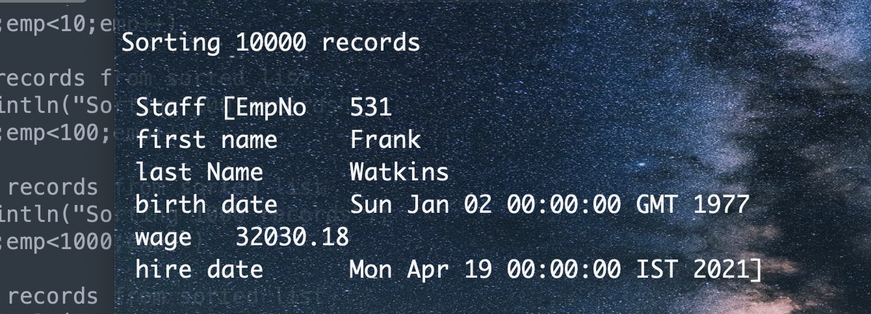

Last sorted record: Dec 31 2021

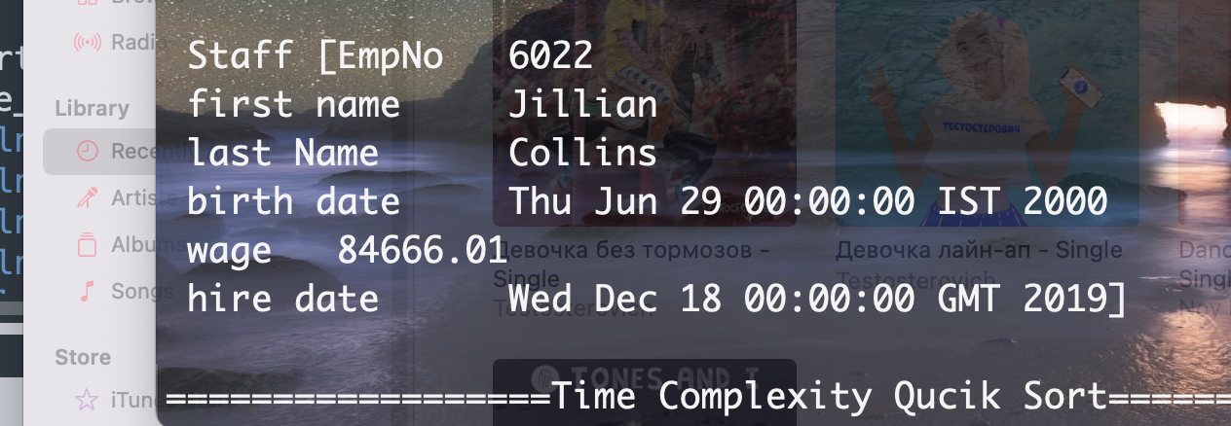

1. Experimentally analyse the time complexity of your sorting algorithm you write for q1 above. Show your results by taking the average elapsed time for 10, 100, 1000, 5000 and 10000 records. **(10 marks)**

ANSWER

QuickSort’s execution time is dependent on the size of the input array and the partition method used.

Following there case scenario:

Worst-Case Scenario O(n2)

The worst-case scenario arises when the partitioning procedure always chooses the largest or smallest element as the pivot. If we take the previous partition technique, in which the final element is always chosen as the pivot, the worst-case scenario occurs when the array is already sorted in ascending or descending order. The following is the frequency of occurrence in the worst-case scenario.

The best-case scenario O(nLogn)

Arises when the partitioning procedure always selects the middle element as the pivot.

Average case O(nLogn)

To do an average case analysis, we must evaluate all potential permutations of the array and compute the time required for each permutation, which does not appear to be simple.

Code for time complexity

**long** start_time_sorting = System.*nanoTime*();

Staff.*quickSort*(staffs, 0, staffs.size()-1);

//Printing 1 records from sorted list

System.***out***.println("Sorting 1 record");

**for**(**int** emp=0;emp<1;emp++)

//Printing 10 records from sorted list

//System.out.println("Sorting 10 records");

//for(int emp=0;emp<10;emp++)

//Printing 100 records from sorted list

//System.out.println("Sorting 100 records");

//for(int emp=0;emp<100;emp++)

//Printing 1000 records from sorted list

//System.out.println("Sorting 1000 records");

//for(int emp=0;emp<1000;emp++)

//Printing 5000 records from sorted list

//System.out.println("Sorting 5000 records");

//for(int emp=0;emp<5000;emp++)

//Printing 10000 records from sorted list

////System.out.println("Sorting 10000 records");

//for(int emp=0;emp<staffs.size()-1;emp++)

{

System.***out***.println(staffs.get(emp).toString());

}

**long** end_time_sorting = System.*nanoTime*();

**long** elapsed_time_sorting = end_time_sorting-start_time_sorting;

System.***out***.println();

System.***out***.println("==================Time Complexity Qucik Sort=============================================================================");

System.***out***.println();

System.***out***.println("Execution time of quickSort in Nano Second: " + elapsed_time_sorting);

System.***out***.println("Execution time of quickSort in Milliseconds: " + elapsed_time_sorting / 1000000);

System.***out***.println("Execution time of quickSort in Second: " + elapsed_time_sorting / 100000000);

System.***out***.println();

System.***out***.println("===========================================================================================================================");

The output of the time complexity

Type of CPU: 2.3 GHz Quad-Core Intel Core i7

Memory: 32 GB 3733 MHz LPDDR4X

Operating System: macOs

The average Time Complexity QuickSort of 10000 records is:

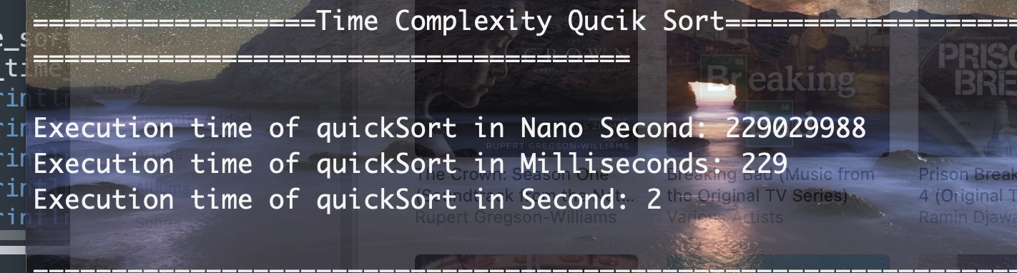

The average Time Complexity QuickSort of 5000 records is:

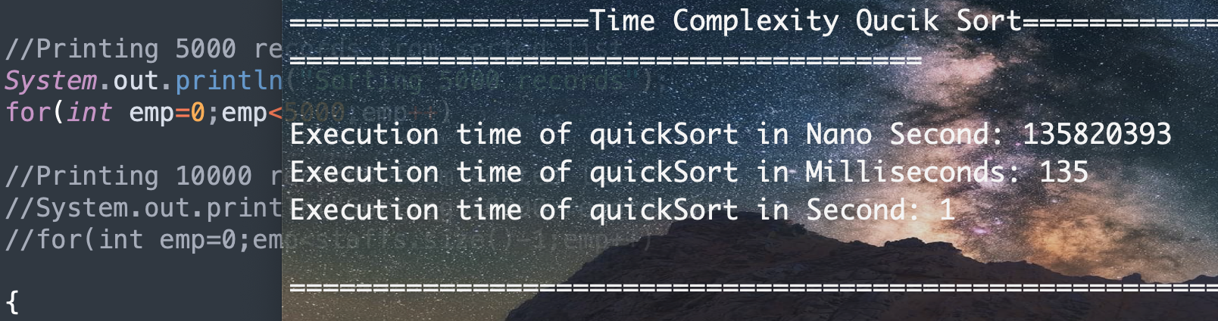

The average Time Complexity QuickSort of 1000 records is:

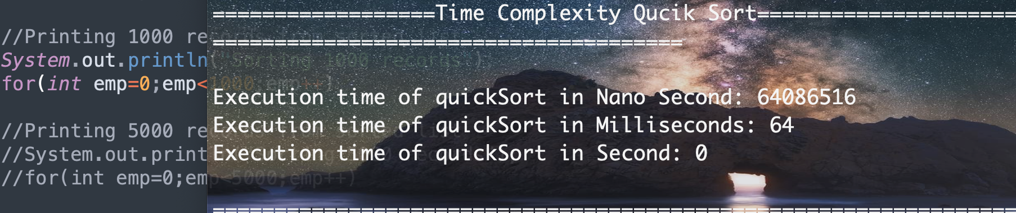

The average Time Complexity QuickSort of 100 records is:

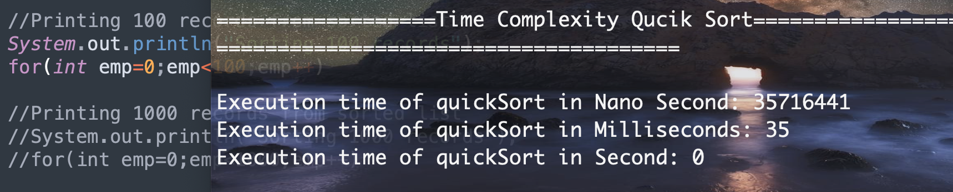

The average Time Complexity QuickSort of 10 records is:

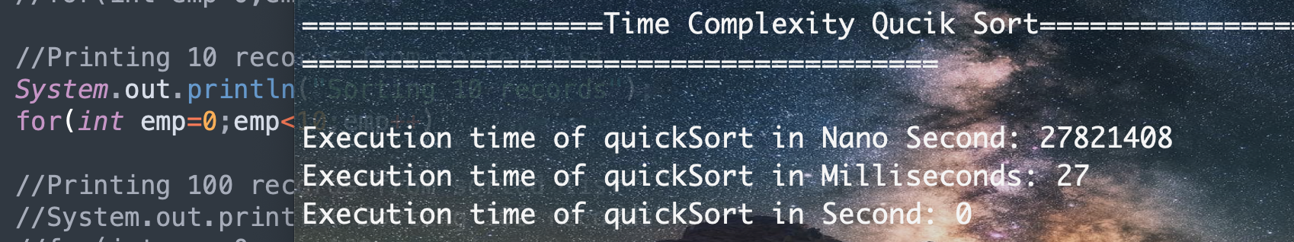

In conclusion, the size of the input is the primary element affecting the time complexity. As the size of the input record increases, the time complexity increases concurrently.

- The average Time Complexity QuickSort of 10: 27821408 nanoseconds, 27 milliseconds, 0 second

- The average Time Complexity QuickSort of 100: 235716441 nanoseconds, 35 milliseconds, 0 second

- The average Time Complexity QuickSort of 1000: 64086516 nanoseconds, 64 milliseconds, 0 second

- The average Time Complexity QuickSort of 5000: 135820393nanoseconds, 135 milliseconds, 1 second

- The average Time Complexity QuickSort of 10000: 229029988nanoseconds, 229 milliseconds, 2 second

1. Write a searching algorithm that accept the sorted column type and searches the data record from the dataset. There could be multiple rows with the same column type. If no X is found, display “Not an existing X!” (Where X is the title of the sorted column like a film title, customer name, item name etc) message. If multiple items have that value return all matches. **(20 Marks)**

***Input:*** 10,000 sorted records,

***Output:*** list of record details with the same associated column label as entered by the user

ANSWER

Binary search algorithm

In the computing world, a binary search algorithm is a commonly used method. It is a large and precise search method that performs well on large and small datasets. A binary search algorithm is an easy-to-implement algorithm. The advantages of time and space analysis are self-evident.

As opposed to sequentially searching through a list, the binary search algorithm divides a list in half on each iteration, rather than doing it sequentially. When dealing with huge lists, this strategy may be quite beneficial.

Binary search algorithm code:

///////////BinarySearch///////////////////////////////////////////////////////////////////////////////////////////////////////////////

/*The algorithm compares the key value to the middle element

*of the array, whether the half is below or above our target value,

* and take that half.

* The half in which the key cannot be part of is eliminated,

* and the search for the remaining half continues until it finds.*/

**static** ArrayList<Integer> binarySearch(ArrayList<Staff> array,Date birthDate)

{

**int** index=*biSearchImpl*(array,0,9999,birthDate);/*The binarySearch method of the Java Arrays class is called with two arguments:

a sortedArray and an int key, which specifies which integers should be searched for in the array of numbers.*/

ArrayList<Integer> index_array = **new** ArrayList<Integer>();

**if**(index!=-1)// if the given array is not empty

{

//check behind the middle point(reversing) the half is less than the target value

**int** i=index-1;

**while** (i>=0)

{ //if the target value is located on determined index then the target values is found.

**if**(array.get(i).getBirthDate().compareTo(birthDate)==0)

index_array.add(i);

**else** // if the target value is not on determined index then continue searching

**break**;

i--;//decrement from middle point until the target value is found

}

//check after the middle point(forward) the half is greater than the target value

i=index+1;

**while**(i<=9999)

{ //if the target value is located on determined index then the target values is found.

**if**(array.get(i).getBirthDate().compareTo(birthDate)==0)

index_array.add(i);

**else** // if the target value is not on determined index then continue searching

**break**;

i++;//increment from middle point until the target value is found

}

**return** index_array;

}

**else**

{

**return** index_array;

}

}

**static** **int** biSearchImpl(ArrayList<Staff> array, **int** left, **int** right, Date birthDate)

{

**if** (right >= left) {// we need to check if the given data is sorted

**int** mid = left + (right - left) / 2;//get the middle point that divides the array into two halves

**if** (array.get(mid).getBirthDate().compareTo(birthDate)==0)

**return** mid;//if the our target value is located on the middle point then the target value is found

// if the target value is less than the middle value then continue searching by decrement until you reach the index of the target value.

**if** (array.get(mid).getBirthDate().compareTo(birthDate)==1)

**return** *biSearchImpl*(array, left, mid - 1, birthDate);

//where the target value is greater than the middle value, then continue searching by increment until you reach the index of the target value

**return** *biSearchImpl*(array, mid + 1, right, birthDate);

}

**return** -1;// the target value is not in the array

}

Implementation BinarySearch code:

System.***out***.println("---------------QUESTIONS 3 && 4-----------");

System.***out***.println();

// Using Binary Search to find records with hire date.

// It returns the ArrayList of indexes

ArrayList<Integer> index_array = **new** ArrayList<Integer>();

//we test our searching method with non existing record.

index_array = Staff.*binarySearch*(staffs, ft.parse("1976-02-24"));

//we test our searching method with existing record.

//index_array = Staff.binarySearch(staffs, ft.parse("1990-02-04"));

**if**(index_array.size()!=0)//if the array is not empty

{

**for**(Integer emp :index_array)

{

System.***out***.println("All Matches\n" + staffs.get(emp).toString());

}

}

**else**

{

System.***out***.println("Not an existing X!" );

}

Output of non existing record

//we test our searching method with non existing record.

index_array = Staff.*binarySearch*(staffs, ft.parse("1976-02-24"));



Output of existing record

//we test our searching method with existing record.

index_array = Staff.*binarySearch*(staffs, ft.parse("1990-02-04"));

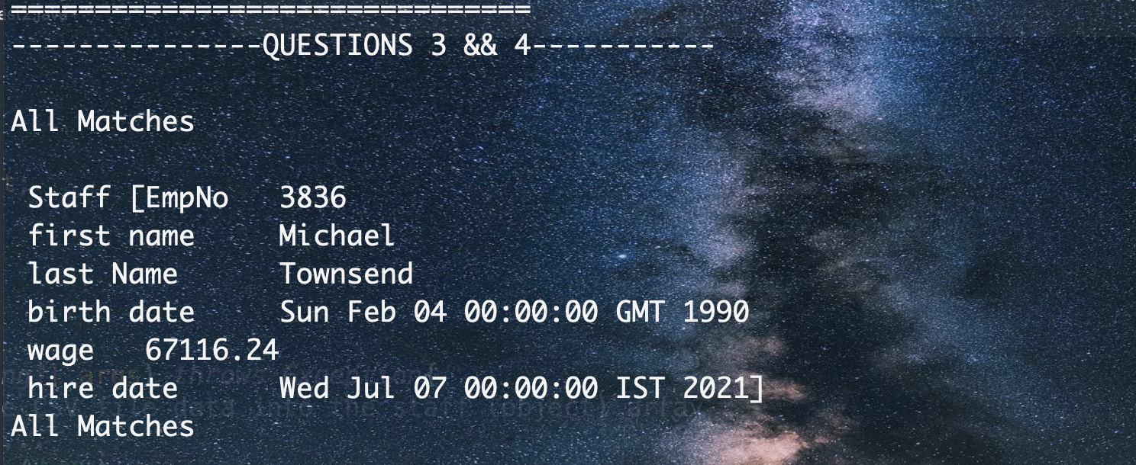

1. Analyse and determine the time complexity of the searching algorithm you write in q3. **(10 Marks)**

ANSWER

The binary search method has a time complexity of O. (log n). The optimal time complexity would be O(1) if the central index matched the target value exactly. The worst-case scenario involves values at either end of the list or values that are not included in the list.

The average and worst case time complexity of binary search is O(log n).

Time Complexity Binary Search code

// Using Binary Search to find records with birth date.

// It returns the ArrayList of indexes

ArrayList<Integer> index_array = **new** ArrayList<Integer>();

**long** start_time_searching = System.*nanoTime*();

//we test our searching method with non existing record.

//index_array = Staff.binarySearch(staffs, ft.parse("1976-02-24"));

//we test our searching method with existing record.

index_array = Staff.*binarySearch*(staffs, ft.parse("1990-02-04"));

**if**(index_array.size()!=0)//if the array is not empty

{

**for**(Integer emp :index_array)

{

System.***out***.println("All Matches\n" + staffs.get(emp).toString());

}

}

**else**

{

System.***out***.println("Not an existing X!" );

}

**long** end_time_searching = System.*nanoTime*();

**long** elapsed_time_searching = end_time_searching - start_time_searching;

System.***out***.println();

System.***out***.println("==================Time Complexity Binary Search================================================================================================================");

System.***out***.println();

System.***out***.println("Execution time of Binary Search in NanoSecond: " + elapsed_time_searching);

System.***out***.println("Execution time of Binary Search in Milliseconds: " + elapsed_time_searching / 1000000);

System.***out***.println("Execution time of Binary Search in Second: " + elapsed_time_searching / 100000000);

System.***out***.println();

Output time Complexity Binary Search of non existing records

The time complexity of O. (log n)./ Average case scenario

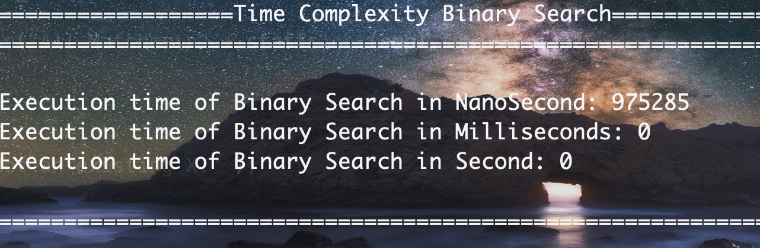

Output time Complexity Binary Search of existing records

The worst-case scenario is due to the record is not included in the date set.

time complexity of binary search is O(log n).

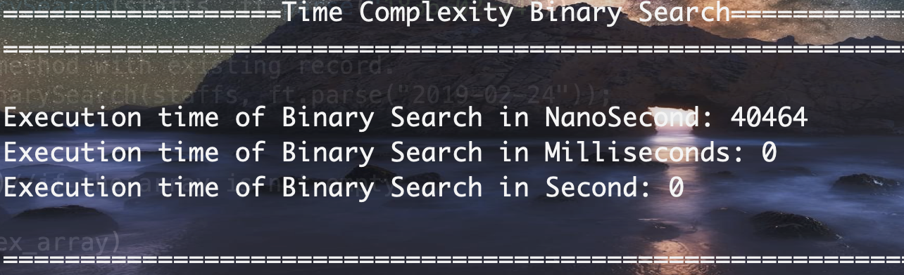

To summarize, the time complexity of binary search with existing records is 40464 nanoseconds, whereas the cost time of searching for non-existent records is 975285 nanoseconds.

Then we may conclude that the time required to search for existing data is less than the time required to search for non-existent data.

**worst-case Defensive Programming and Exception Handling**

1. Write a Java program that accept new record (with all the six fields) and add it at the end of the record with a new consecutive id number (like emp_no, film_id, or stock_no after the last item). **(10 Marks)**

**Example Input for staff**:"Joe", "Bloggs", 1990-02-10, 10000, 2020-01-01

**Example Input for film**: (“comedy”, “2006-01-01”, “Marley and me”, 2.3, 2.50)

**Example Input for stock**: (12.2, 120.3, “furniture”, 2015-01-10, ”L-Sofa”)

Code for part 2

//Part 2: Defensive Programming and Exception Handling

//Questions 1, 2, 3

// New record input validation and testing

//Question 1 accept new record

System.***out***.println("===============================================================================================================================================================");

System.***out***.println();

System.***out***.println("Part 2: Defensive Programming and Exception Handling");

System.***out***.println("Questions 1, 2, 3");

System.***out***.println();

System.***out***.println("Input new record : ");

Scanner scan = **new** Scanner(System.***in***);

**while**(**true**)

{

//Using Scanner class to accept user input

String input = scan.nextLine();

/*Substring is a frequently used method in the java lang package.

* String class that is used to split larger strings into smaller ones.

* Because strings in Java are immutable, the old string is preserved,

* and the method returns a new string.*/

input = input.substring(1,input.length());

String[] data = input.split(",");

//System.out.println(data[2]);

//Date d1=ft.parse(data[2]);

**boolean** tmp=Staff.*validate*(data);

**if**(tmp==**true**) ////returns a boolean value

{

//determining the input data and increasing the data set size by 1 once a new record has been entered. [new Staff(staffs.size()+1].

// add: first name, last name,

staffs.add(**new** Staff(staffs.size()+1, data[0], data[1], ft.parse(data[2]), Float.*parseFloat*(data[3]), ft.parse(data[4])));

**break**;

}

}

System.***out***.println(staffs.get(staffs.size()-1).toString());

Accepting a new record from the user and add it in the data set as new employee.

Input:"Joe", "Bloggs", 1990-02-10, 10000, 2020-01-01

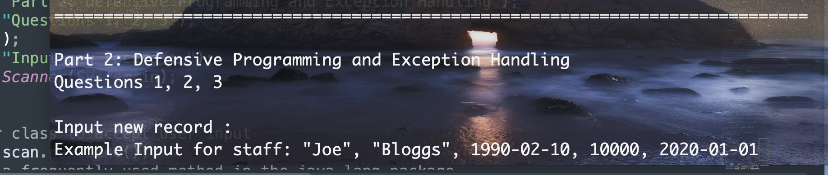

Output

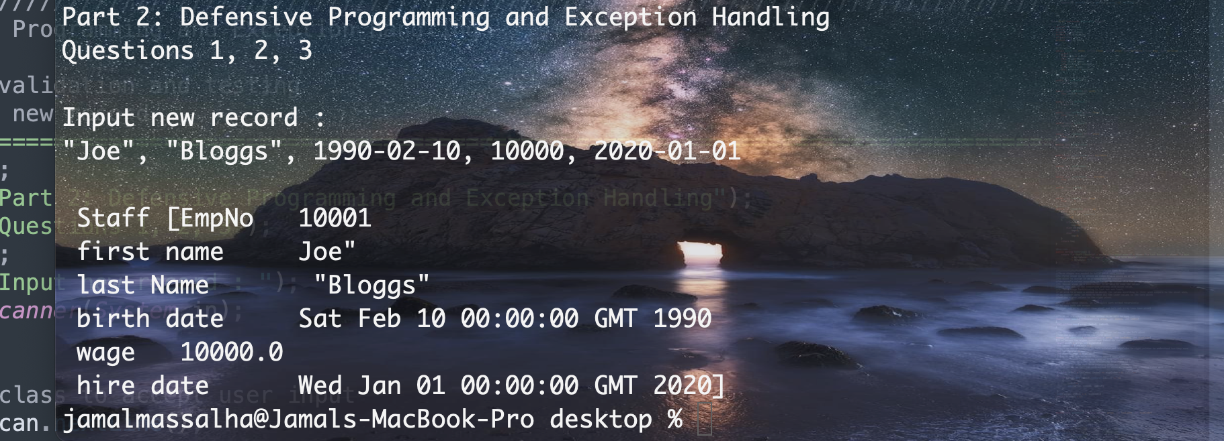

The size of the data set increased by 1 once the record had been added.

1. If using the Staff.csv file do the following:

Write a Java method that checks the correct values of the birth_date . The birth_date should not be less than 01-01-1950. Also, the company should not hire employees younger than 18 years (current year –18).

**Example Invalid input:** Birth_date = 1945-04-02 (above retirement age)

**Example Invalid input:** Birth_date = 2010-10-03 (below the employment age)

Code for validation Birth date input

**static** **boolean** validate(String[] data) **throws** Exception

{ //This programme has been developed to validate the user input, and throw an exception in case the input are not matching the program conditions, and allowing the user to enter again

//using throws an exception to suppress the error that might occur.

//Birth Date Validation

SimpleDateFormat ft = **new** SimpleDateFormat ("yyyy-MM-dd");

Date d1 = ft.parse("1950-01-01");// reference date to able to validate the input birth date

Date bDate = ft.parse(data[2]);// applying the validation on data[2] where the birth date located in the data set

**if**(bDate.compareTo(d1)==-1)// we compare the input date with fixed condition "1950-01-01"// if the given date birth is lower than "1950-01-01" its above retirement age,

{

System.***out***.println("Invalid Birth Date (above retirement age), It should be greater than 1950-01-01");

**return** **false**;

} //Age Validation

Date hire_date=ft.parse(data[4]);// applying the validation on data[4] where the hire date located in the data set

**long** time_difference = hire_date.getTime() - bDate.getTime();// taking the hire date and subtracting it from the birth date to get the precise age

**long** years_difference = (time_difference / (1000*60*60*24*365)); // here is the formula to calculate the exact age.

**if**(years_difference<18)// company should not hire employees younger than 18 years

{

System.***out***.println("company should not hire employees younger than 18 years");

**return** **false**;

}

Input valid birth date: "Joe", "Bloggs", 1990-02-10, 10000, 2020-01-01



Output



Input invalid birth date = 1945-04-02 (above retirement age)

"Joe", "Bloggs", 1945-04-02, 10000, 2020-01-01

Output

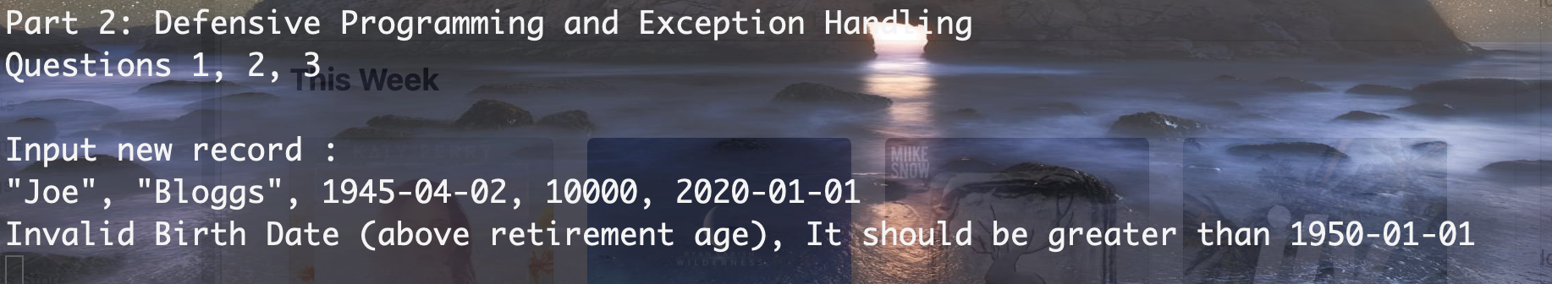

Input invalid birth date = 2010-10-03 (below the employment age)

"Joe", "Bloggs", 2010-10-03, 10000, 2020-01-01

Output

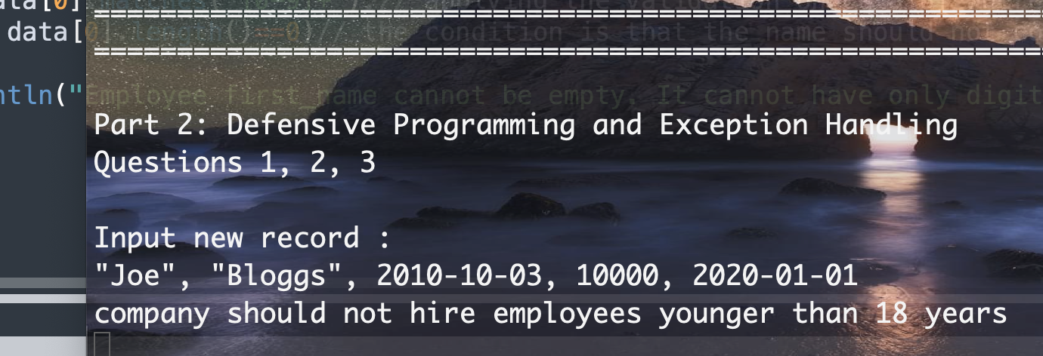

**(15 Marks)**

1. Write a Java Exception that handles special cases and communicate to users to correct the cases. A typical special case is that the first_name field cannot be empty or cannot contain digits only. The exception should generate “Employee first_name cannot be empty. It cannot have only digits! Please correct this” message. **(15 Marks)**

**Staff example:**

**Example Invalid input**: first_name = 2343322

**Example Invalid input:** first_name =””

Code Name Validation

//First Name Validation

**boolean** result = data[0].matches("[0-9]+");// applying the validation on data[0] where the first name located in the data set

**if**(result==**true** || data[0].length()==0)// the condition is that the name should not contains number or cannot be left empty

{

System.***out***.println("Employee first_name cannot be empty. It cannot have only digits! Please correct this");

**return** **false**;

}

**return** **true**;

}

Valid input

"Joe", "Bloggs", 1990-02-10, 10000, 2020-01-01



Output



**Invalid input**: first_name = 2343322

2343322, "Bloggs", 1990-02-10, 10000, 2020-01-01

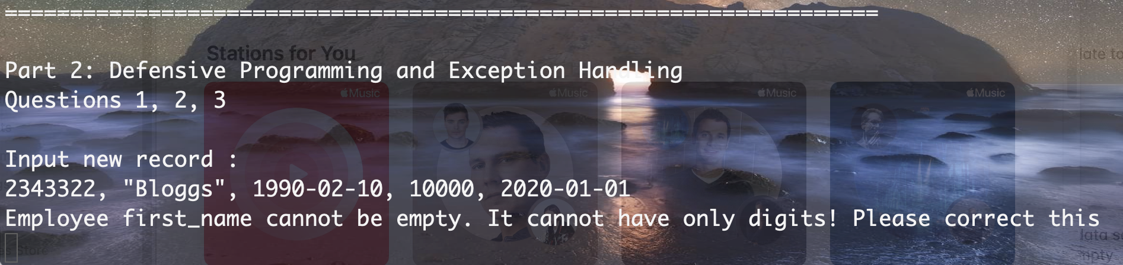

**Invalid input**: first_name = “ ” Empty

, "Bloggs", 1990-02-10, 10000, 2020-01-01

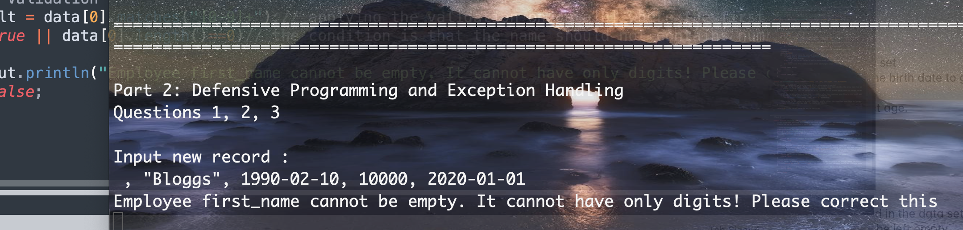

**Available Resources:**

1. A csv file containing 10,000 records is available for download from your Moodle page.
2. A Java snippet to read the csv file will be made available. You may use the code to load your data, or you may build your own way of reading the records from the csv file.
3. You may use a suitable data structure to represent the employee information.
4. You may use any Java IDE to complete your assignment.

**Submission Checklist:**

1. A pdf/word document containing the answers to each of the above questions. Include any textual description, justification and assumptions along with your answers. It should contain any input-process-output descriptive diagrams to communicate some functions in the programs.
2. A Java source file containing the implementation for the questions. Write your methods to the respective classes and provide the question number as a comment on top of your methods. Java compiled class will not be accepted.
3. Make sure all your code compiles correctly and all required packages are imported correctly.

**Submission Guideline:**

The submission link will have two parts.

Part 1. Document upload (upload your pdf/word file here)

Part 2. Java code upload (upload a single zip file containing your classes and methods)

**Naming Convention:**

[YourID]_[YourProgramCode]_[YourLastName]_[YourFirstName]_AAP_Description.doc/pdf

[YourID]_[YourProgramCode]_[YourLastName]_[YourFirstName]_AAP.Zip

**Example:**

* + X21118426_ HDSDEV_INT _Jamal_Massalha_Description.doc
  + X21118426_ HDSDEV_INT _ Jamal_Massalha_Code.zip

**Submission Deadline:** 11-04-2022 @23:55